 



FLOE NAVIGATION SYSTEM

ADMINISTRATOR GUIDE

RELEASE 1.0.0

DECEMBER 2018

Nadeem Gul

Rintu Daniel

Contents

Preface: i

Audience: i

Related Documents: i

1. Getting Started 1

2. Dashboard 2

2.1 Status Bar 3

3. Grid 4

3.1 Coordinate System: 4

3.2 Map View 5

3.2.1 Features 6

4. Deployment 13

5. Waypoint 17

6. Sample/Measurement 22

# Preface:

Welcome to the Floe Navigation Android Application. The application can be installed on any Android tablet (For the MOSAiC expedition the tablet being used is [XSLATE D10](https://www.xploretech.com/downloads/Marketing_Brochures/D10/XSLATE_D10_Specsheet_EN.pdf)). This application uses the periodic data from AIS transponders installed on the Sea Ice to create a coordinate system which is fixed on a moving ice floe. It creates a visual representation of the coordinate system in the form of a grid which can be used to navigate on a moving Sea Ice.

Please read through this document thoroughly before you start to use the Floe Navigation App. The purpose of this guide is to provide configuration and administration guidelines for the Floe Navigation Android App and the Synchronization Server.

## Audience:

This document is intended for the Administrators of the Floe Navigation System application.

Related Documents:

For more information, see the following documents:

* Floe Navigation User Guide
* Floe Navigation Developer Guide

# Getting Started

Please read through the following necessary and important configurations that need to be done in the Android environment to ensure the smooth operation of the Floe Navigation App.

* The App needs an AIS Transponder to run. Ensure that the tablet is connected to the Wi-Fi network of an AIS transponder.
* Make sure that only one Tablet is connected to the Wi-Fi network of an AIS Transponder, as the AIS transponders do not support multiple client connections.
* Make sure that the location on the Android device is enabled. For details visit [Android documentation](https://support.google.com/accounts/answer/3467281?hl=en).
* Make sure that the Tablet is not connected to any other network interfaces such as Ethernet/GPRS and only a Wi-Fi network of an AIS Transponder is connected.
* For smooth operation, it is recommended that there are no other apps running on the device when the Floe Navigation App is running.

# System Overview

Explain coordinate system in detail.

# Accessing Administrator Dashboard

The Admin Dashboard can be opened from the Main Dashboard of the Floe Navigation App. The Admin Dashboard can only be accessed with valid user credentials.

The Floe Navigation app is pre-configured with a default username and password.

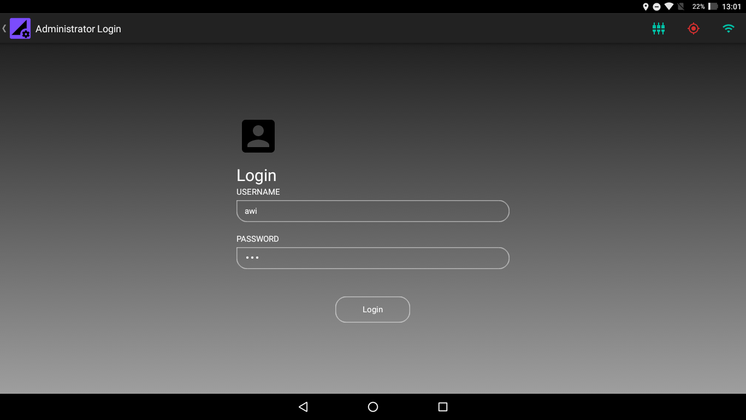

Figure 3.1 Administrator Login Screen

The pre-configured user credentials are:

Table 3.1 Default User Credential

|  |  |
| --- | --- |
| **Username** | **awi** |
| **Password** | **awi** |

Refer to section for User Administration.

On successful login the Administrator Dashboard is displayed.

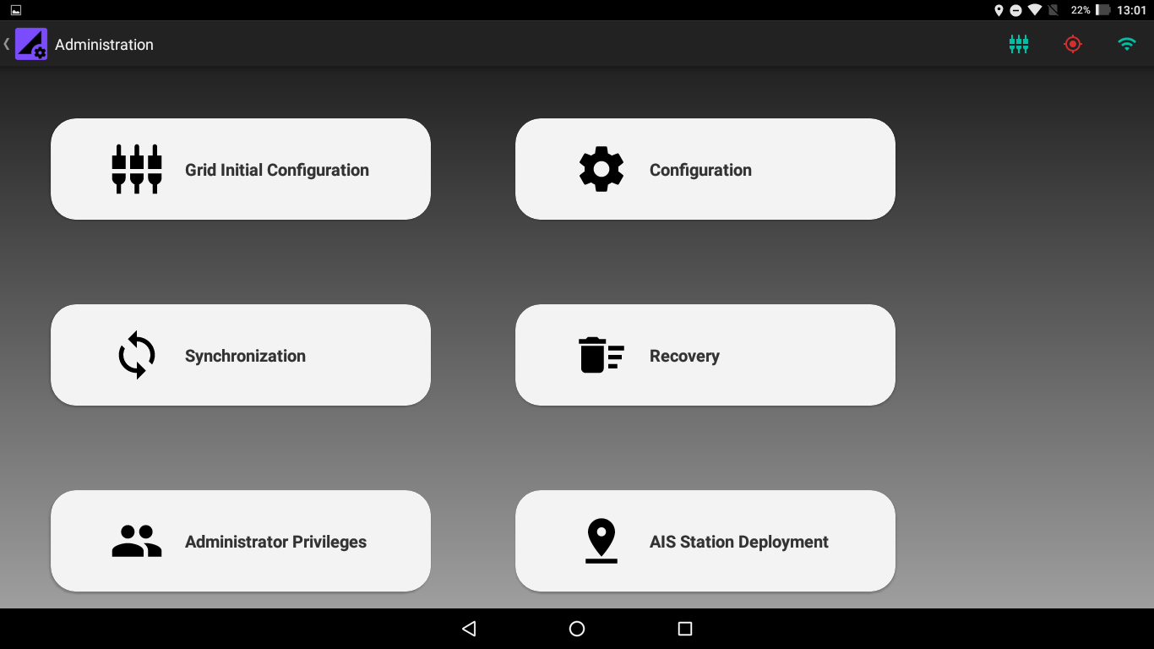

Figure 3.3.1 Administrator Dashboard

# Setting Up the Coordinate System

The Floe Navigation system needs at least two AIS Transponders installed as Fixed Stations on the Sea Ice to create its coordinate system (For details about the Coordinate system check Floe Navigation User Guide Chapter 3). The coordinate system needs to be established on only one tablet and it can be replicated in the other tablets using Synchronization (insert Hyperlink).

The coordinate system can only be established by an administrator and it is recommended that you set up the coordinate system immediately after installation of the app.

To start setting up the coordinate system access the Administrator Menu as described in Chapter 2. When accessing the Admin Menu for the first time the App will display a dialog box asking you to set a Unique Tablet ID for the tablet. This will be done only once, however, the tablet ID can be reviewed and reset from the Configuration Menu (insert Hyperlink). The Tablet ID needs to be set for each tablet separately.

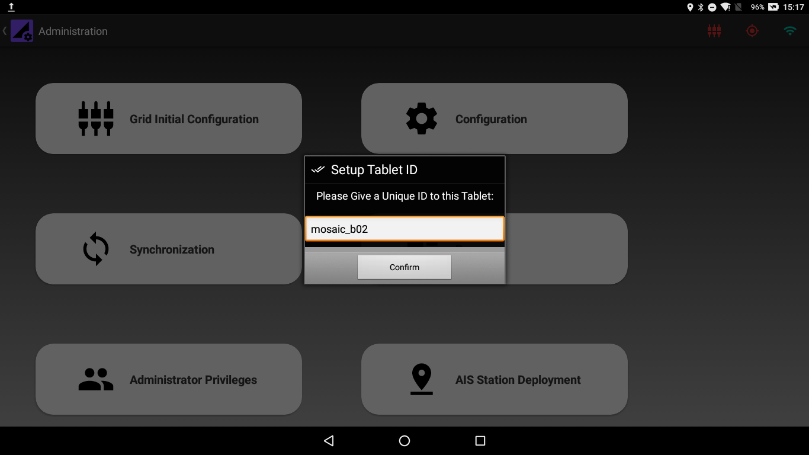

Figure 4.1 Tablet ID Dialog Box

Once the tablet ID is set, you can start setting up the tablet. However, it is highly recommended to check the value of the INITIAL_SETUP_TIME parameter in the Configuration Menu before setting up the coordinate system. The default value for the INITIAL_SETUP_TIME parameter is 30 minutes. For details about the Configuration Parameters check (insert Hyperlink)

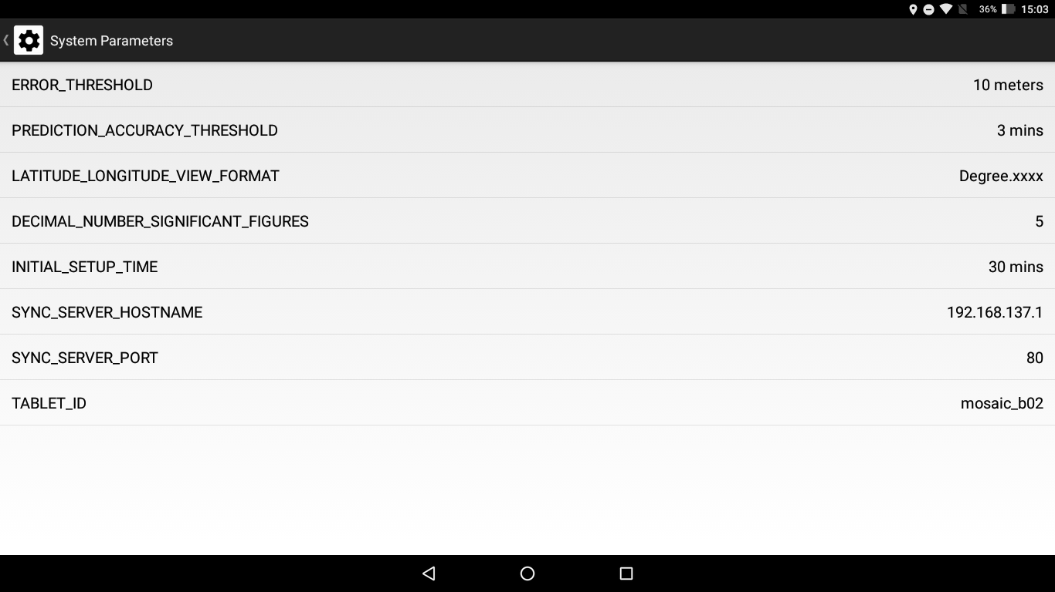

Figure 4.2 Configuration Parameters

To set up the coordinate system enter the Grid Initialization menu from the Administrator Dashboard and perform the following steps. **It is imperative that you perform the following steps in one go and do not close or minimize the app or press the back button, while the setup is in progress**:

1. Provide the Name and MMSI of the first AIS Transponder. Please note that the location of the first AIS Transponder will become the origin of the coordinate system.

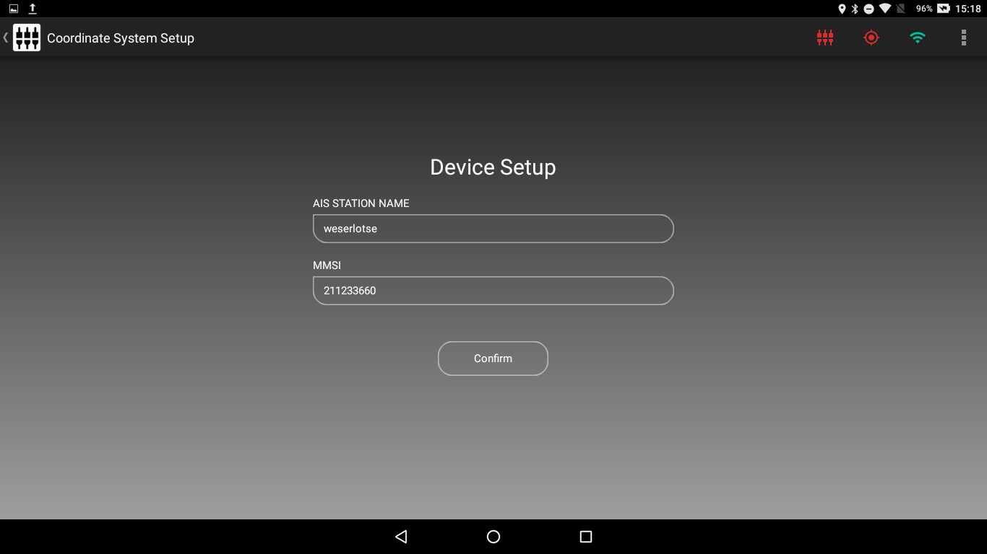

Figure 4.3 Setting up an AIS Transponder

1. If a correct MMSI number is entered and confirm is pressed the app will enter that MMSI number in its internal database and wait for a packet from the corresponding AIS Transponder.

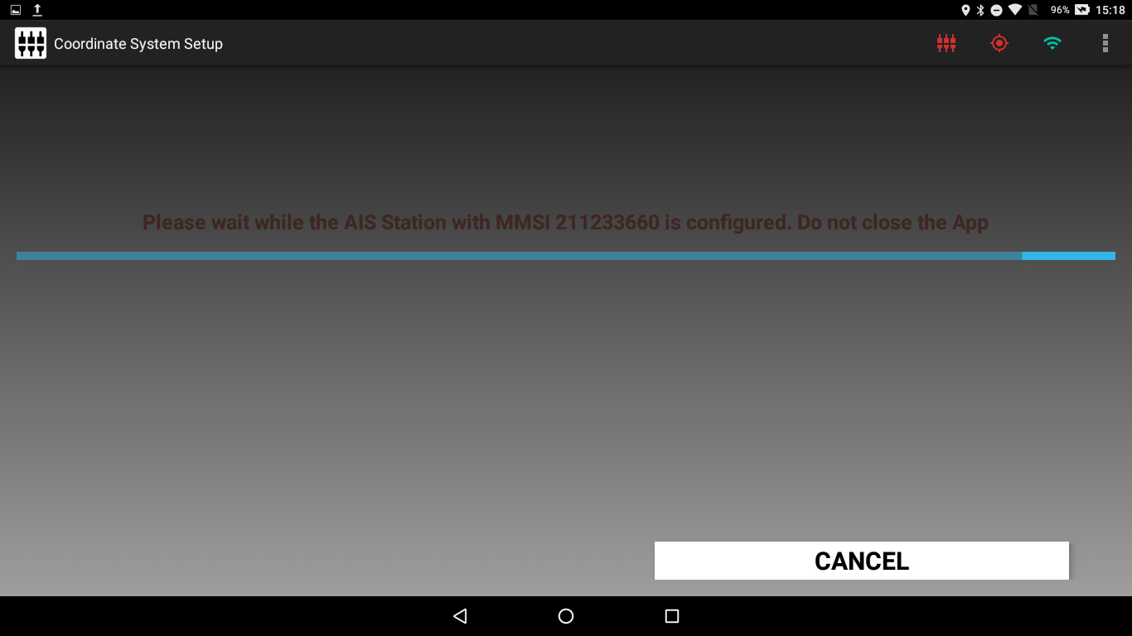

Figure 4.4 Waiting for an AIS Packet

If a packet is not received for 5 minutes or the cancel button is pressed the MMSI will be removed from the internal database and you will be redirected to Step 1.

1. When a valid packet with location data is received from the AIS Transponder the App will display the location details received along with the location of the tablet.

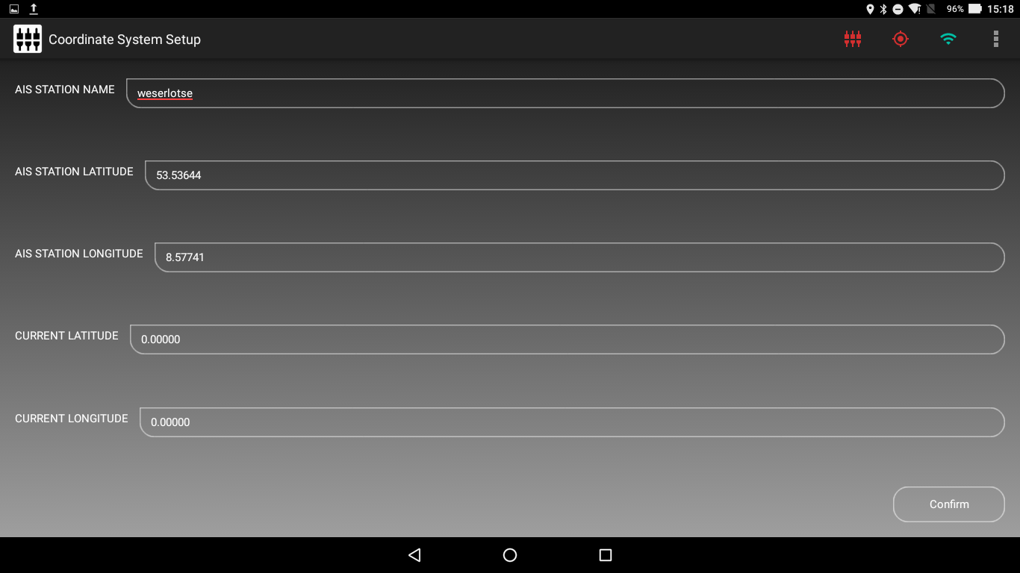

Figure 4.5 AIS Transponder Received Location Data

The format of the coordinates being shown on the screen can be changed from decimal to Degree (°) Minutes (‘) Seconds (‘’) using the Change Lat/Lon Format from the Action Bar.

(insert image for change Lat lon format)

1. When confirm is pressed the AIS transponder is installed in the App as a Fixed Station.
2. Repeat Steps 1 through 4 for installing the second AIS Transponder which will mark x-Axis of the coordinate system.
3. When the second AIS Transponder is also installed, the app runs the Coordinate System Setup during which the App will continuously predict a new location for each of the installed AIS transponders on the basis of the previously received AIS location data and compare the predicted locations with the locations received from the corresponding AIS transponders. The app also calculates and compares *Beta (β)* from the received as well the predicted locations. The app will show the differences in the received and predicted parameters for each AIS Transponder on the screen.

The coordinate system setup will run for the time specified in the INITIAL_SETUP_TIME parameter.

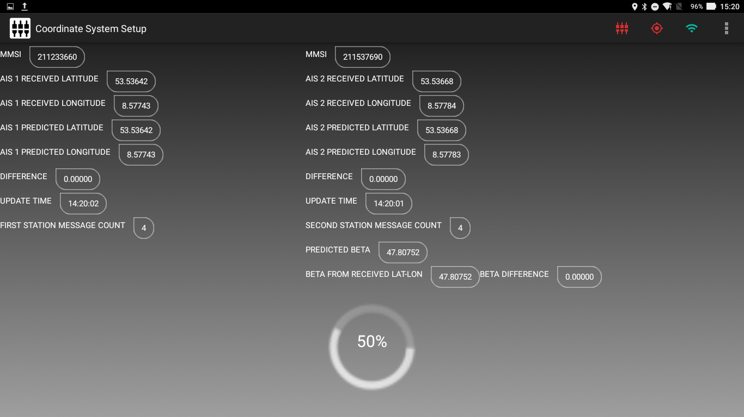

Figure 4.6 Coordinate System Setup

1. When the setup has run for INITIAL_SETUP_TIME it will stop predicting new values and you can check the differences in received and predicted values. Pressing Next will open a Dialog Box which gives you an option to rerun the setup for the same time again if you are not satisfied with the differences. If you rerun the setup the App will continue to predict new values from the previous results which can help in minimizing the differences by taking in more data points.

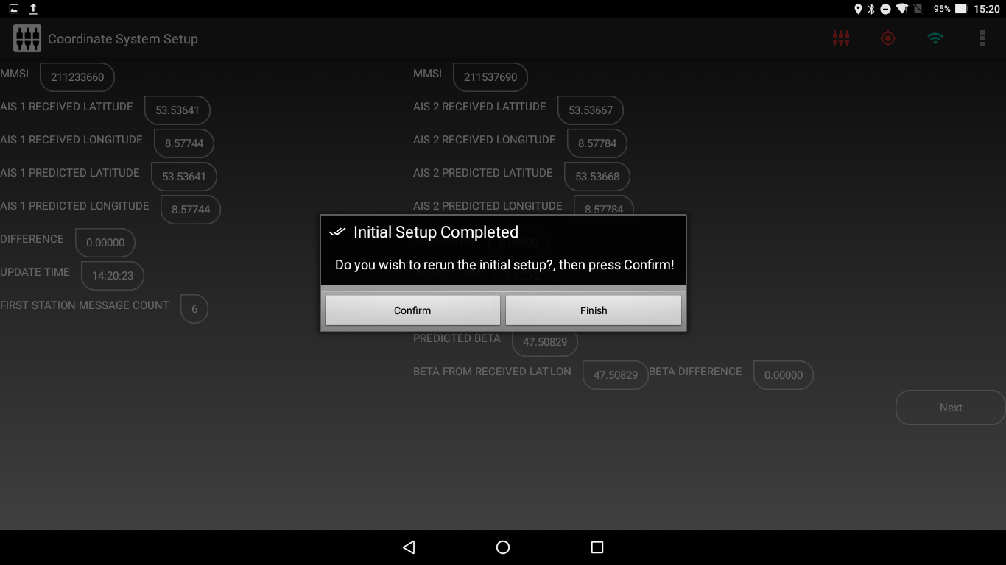

Figure 4.7 Rerun Setup if Difference is not small

1. If you are satisfied with the differences press finish on the Dialog Box and the Coordinate System for the App will be established. The App will start running the essential services of the App (Refer to System Overview).
2. The App will open the Main Dashboard and now the App can be used by the User. (Refer to Floe Navigation User Guide).

# Synchronization

As explained in Chapter 2 to ensure that all the tablets are working with the same data, we need to synchronize them with each other using the Sync Server. The synchronization process ensures that all the important data which is used to create and maintain the coordinate system remains same in all the tablets.

**When the coordinate system has been established on one tablet you must Synchronize that tablet with the Sync Server and pull that data in the rest of the tablets in use to setup the coordinate system in other tablets. This helps in maintaining a uniform coordinate system in all the tablets. The Device list which is used to take Sample/Measurement is also imported with the Synchronization process.**

To Synchronize a tablet with the Sync Server, follow these steps:

1. Check the parameters SYNC_SERVER_HOSTNAME and SYNC_SERVER_PORT in the Configuration Menu to ensure that they are set correctly.
2. Access the Synchronization Menu by pressing the Synchronization button on the Administrator Dashboard.
3. Please make sure that the tablet is connected to the same network as the Sync Server and not connected to a Wi-Fi network of an AIS Transponder.
4. On pressing Start Sync the app will stop its services and push the data from the internal database on the tablet to the Sync Server.

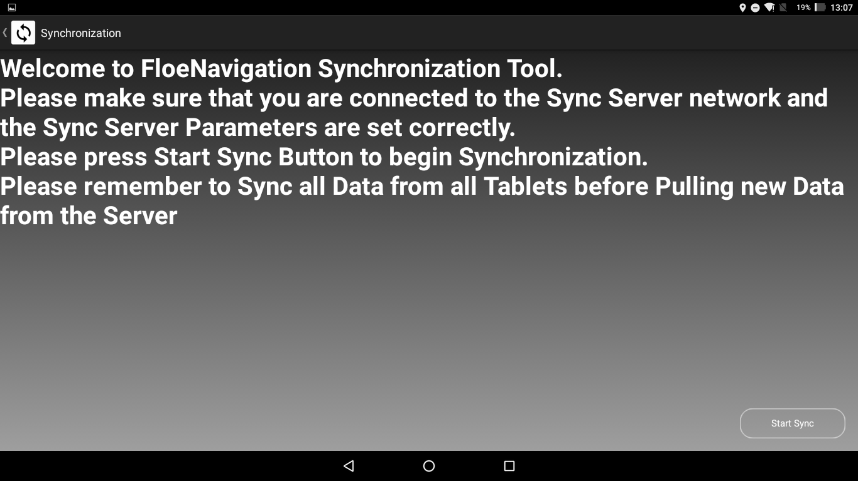

Figure 5.1 Synchronization Main Screen

If the tablet cannot find the server specified by the SYNC_SERVER_HOSTNAME it will display a message to that effect and no data will be pushed.

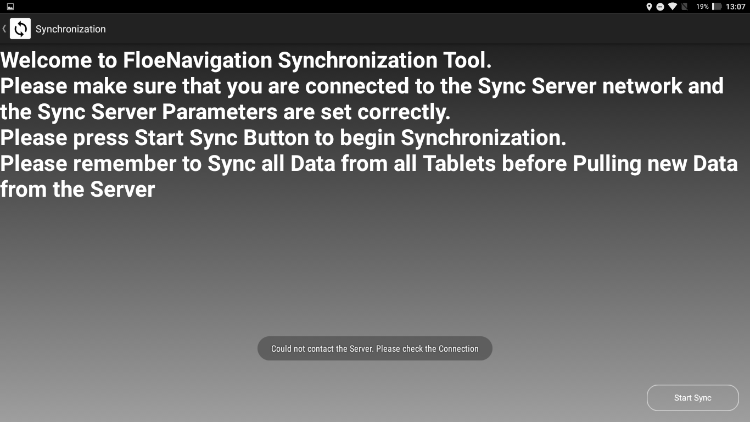

Figure 5.2 Tablet could not find the Sync Server

1. Once the data is pushed the app will wait until data from the other tablets is also pushed to the Sync Server. You should push data from the other tablets that are in operation. **It is imperative that you perform push data from other tablets before starting to pull data from the server and do not close or minimize the app or press the back button, while the app is synchronizing**.

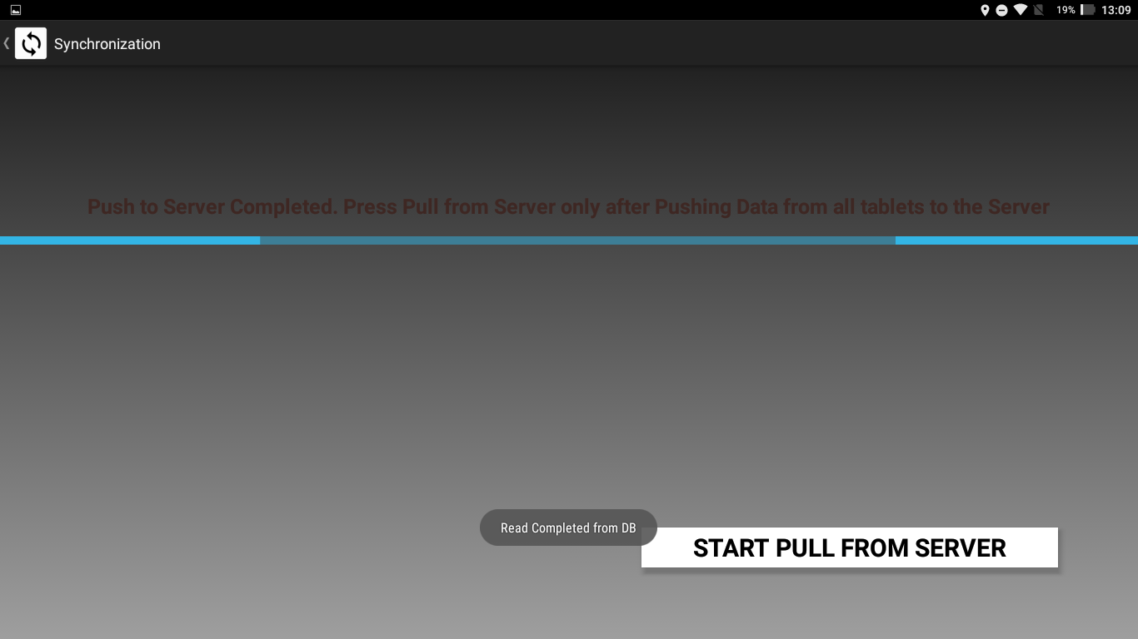

Figure 5.3 Synchronization Progress: Data Push Completed

1. Once you have pushed data from all the tablets to the Sync Server press *START PULL FROM SERVER* to start pulling the Synchronized Data from the Server. Once the data is pulled the App will restart its services and open the Administrator Dashboard. The app will now use the updated data from the Sync Server and you can now connect the app to the Wi-Fi network of an AIS Transponder once again.

# AIS Station Deployment

To deploy a new AIS Fixed Station follow these steps:

1. Press AIS Station Deployment from the Administrator Dashboard to start the deployment process.
2. Give the Station Name and MMSI, and select Station Type from the drop-down menu for the new station to be deployed on the grid and press confirm button.

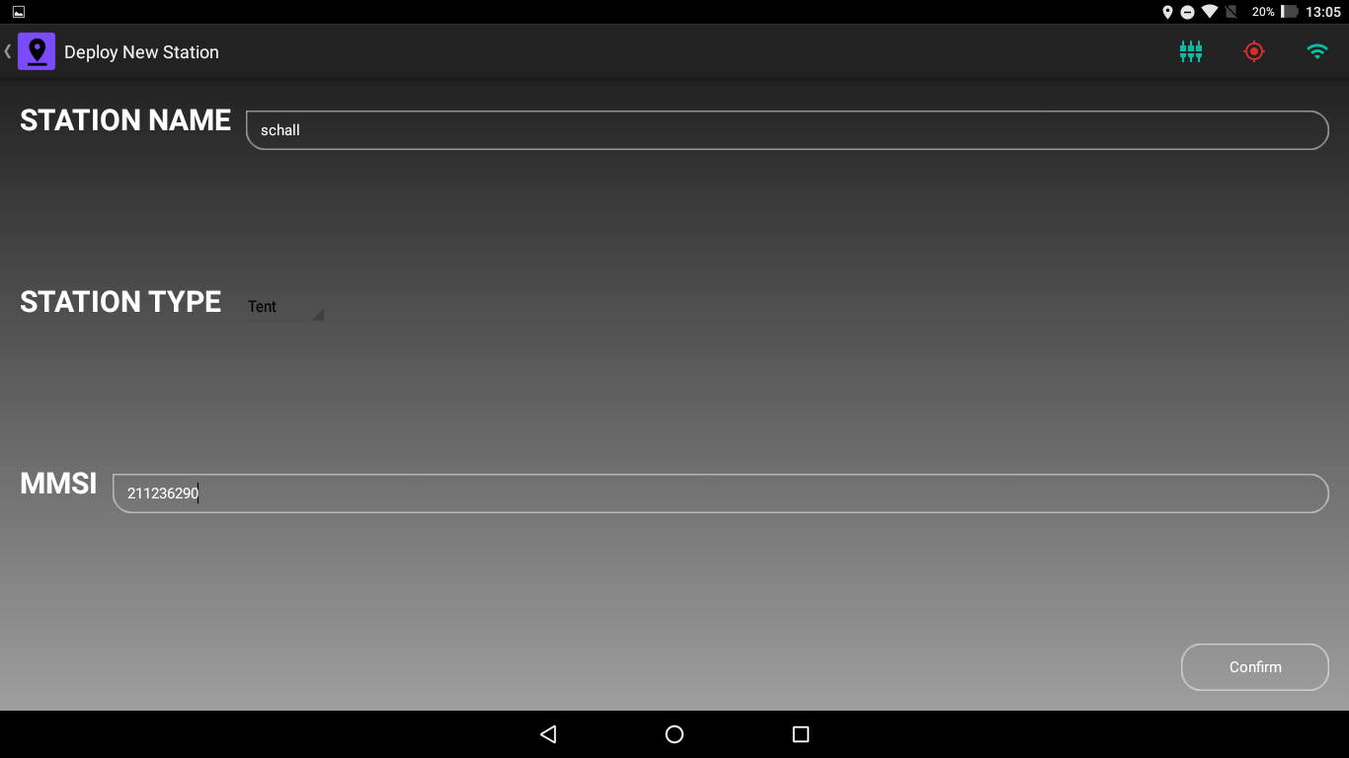

Figure 6.1 AIS Station Deployment Screen

1. If a correct MMSI number is entered and confirm is pressed the app will enter that MMSI number in its internal database and wait for a packet from the corresponding AIS Transponder.

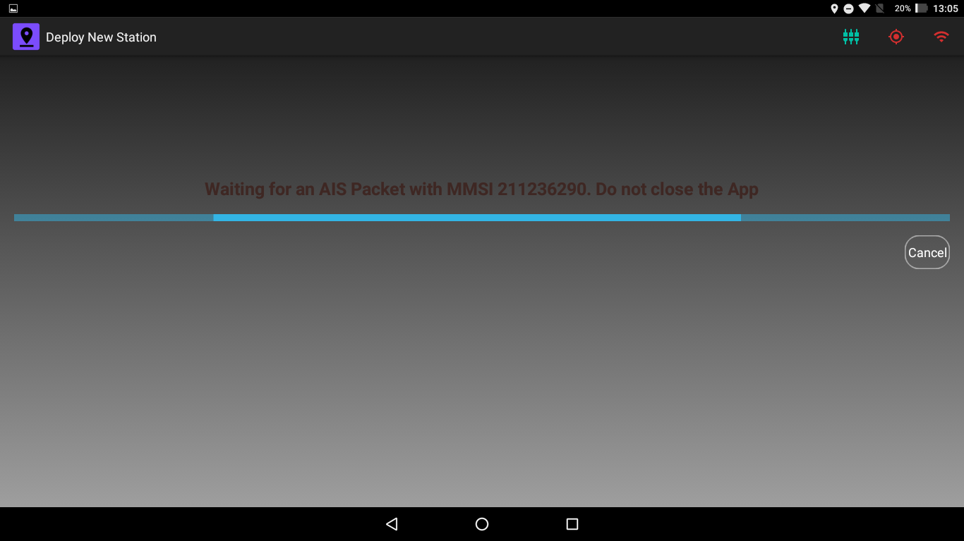

Figure 6.2 Waiting for an AIS Packet

If a packet is not received for 5 minutes or the cancel button is pressed the MMSI will be removed from the internal database and you will be redirected to Step 2.

1. When a valid packet with location data is received from the AIS Transponder, it is installed in the App as a Fixed Station and it is now visible in the Grid.

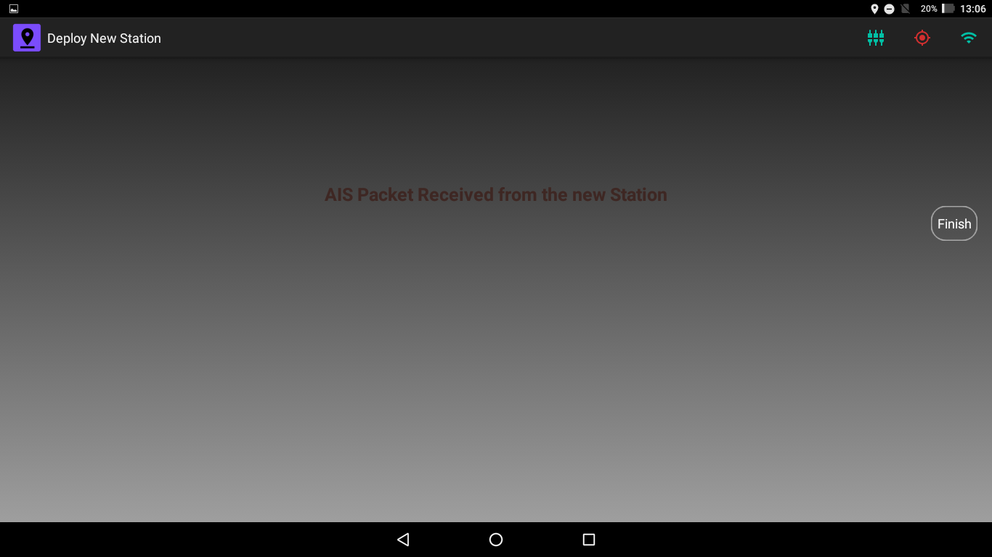

Figure 6.3 AIS Transponder Received Location Data and Installed as Fixed Station

1. Pressing Finish button will take you back to the Administrator Dashboard.

## Status Bar

The status bar shows important indicators regarding the connectivity and configuration of the app.

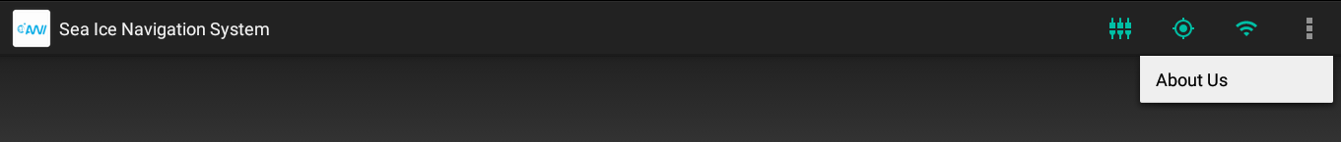

Figure 6.4 Status Bar on Android Device

The icons which are shown in the status bar are:

**Table 2.1 Status Bar Icons**

|  |  |  |
| --- | --- | --- |
| **Icon Name** | **State** | **Description** |
| Grid Setup Complete |  | Green: Grid Setup is complete and the App can be used completely. |
|  | Red: Grid Setup is not completed and you cannot access any functionality of the App. Check Floe Navigation Administration Guide for instructions on configuring the App. |
| Location Available |  | Green: The Device location is available. The App also uses the GPS time to record all the data. |
|  | Red: The device location is not available. Make sure that GPS is enabled. Refer to Chapter 1. |
| Wi-Fi Connection |  | Green: The Device is connected to a Wi-Fi network. |
|  | Red: The device is not connected to a Wi-Fi network. Make sure that Wi-Fi is enabled. Refer to Chapter 1. |
| About Us |  | Shows the About Us Dialog box containing Legal and Developer information. |

# Grid

This chapter describes the Floe Navigation Grid and the coordinate system on which it is established.

## Coordinate System:

The basic aim of the Floe Navigation system is to create a coordinate system which remains static with respect to a moving sea ice. To that end, it uses data from two AIS transponders to set up the coordinate system (For details about AIS see [here](https://en.wikipedia.org/wiki/Automatic_identification_system)). The coordinate system can only be established by an administrator of the system. For details see Floe Navigation Administrator Guide.

The custom coordinate system is created by fixing one AIS transponder as the origin and the other transponder is used to mark the x-Axis of the coordinate system. The y-Axis is then considered as perpendicular to the x-Axis. The custom coordinate system so created moves with the flowing sea ice as the transponders move with it. The positions of the points of interest on the sea ice can then be calculated relative to the custom coordinate system. So that each point of interest on the sea ice will have a {x, y} coordinate pair.



Figure 7.1 Coordinate System Concept at Setup

The Grid is a visual representation of all the above-mentioned coordinate system along with all the points of interests marked on it. The points of interest can be Waypoints, Static Stations (Stations without AIS), Mobile Stations (moving vehicles with AIS) and Fixed Stations (Stations with AIS). The grid also shows the tablet’s current position (own position) on the coordinate system for determining your position on the grid and the position of the mothership.



Figure 7.2 Coordinate System concept with all Points of Interest

## Map View

The Map View is the visual representation of the coordinate system established on the sea ice. The Map View shows all the points of interest that have been installed on the Sea Ice. The Map View shows all the stations and points of interest in a 100 km radius from the origin. There are vertical and horizontal scales on the left side and bottom of the Map View. The scales are in kilometers by default however when zoomed in, it automatically changes the scales to meters.

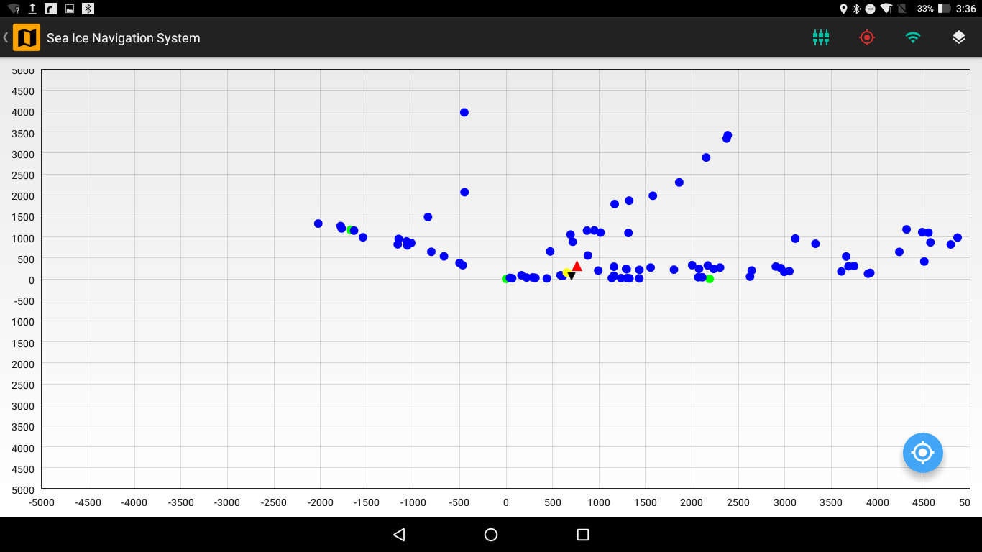

Figure 7.3 Map View of Coordinate System with Points of Interest

### Features

Several sophisticated features are available in the map view to aid you in visualizing the map view of the sea ice.

#### Layers

There are different layers on the Map View and you can set the visibility of each layer. The tablet location is always visible. By default, the visibility of all the layers is set on the Map View.

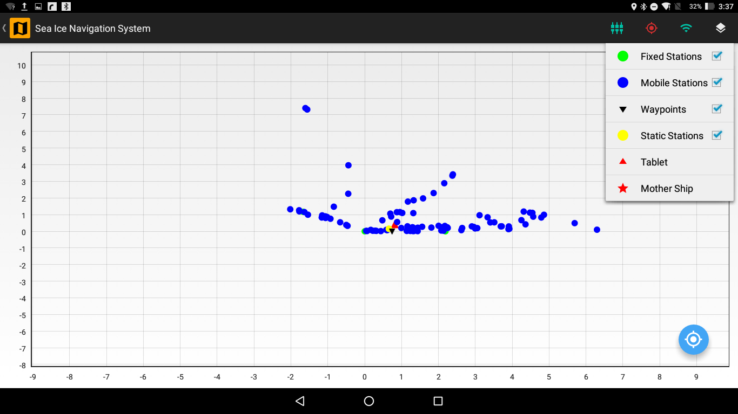

Figure 7.4 Map View with the available layers

The Layers that are visible on the Map View are:

**Table 3.1 Available Layers in Map View**

|  |  |  |
| --- | --- | --- |
| **Layer** | **Icon** | **Description** |
| Fixed Station |  | These are fixed position on the ice where AIS transponders have been mounted. Deployment of such station can only be done by an administrator (refer to Floe Navigation Administrator Guide for details). The periodic AIS data from these stations is used by the App to maintain the coordinate system. |
| Mobile Station |  | These are vehicles which are moving on the Sea Ice and have an AIS transponder mounted on them. The Map View will show all the mobile stations in a 100km radius. |
| Waypoints |  | These are points of interest on the Sea Ice. For details refer to Chapter 5. |
| Static Stations |  | These are fixed position on the ice without an AIS transponder. You can deploy such stations using the Deployment section (For details refer Chapter 4). |
| Own Position |  | This shows your current location on the Map View relative to the custom coordinate system. |
| Mother Ship |  | This is a special type of Mobile Station which shows the position of the Mother Ship. |

The screenshots of the different layers on the Map View are shown below:

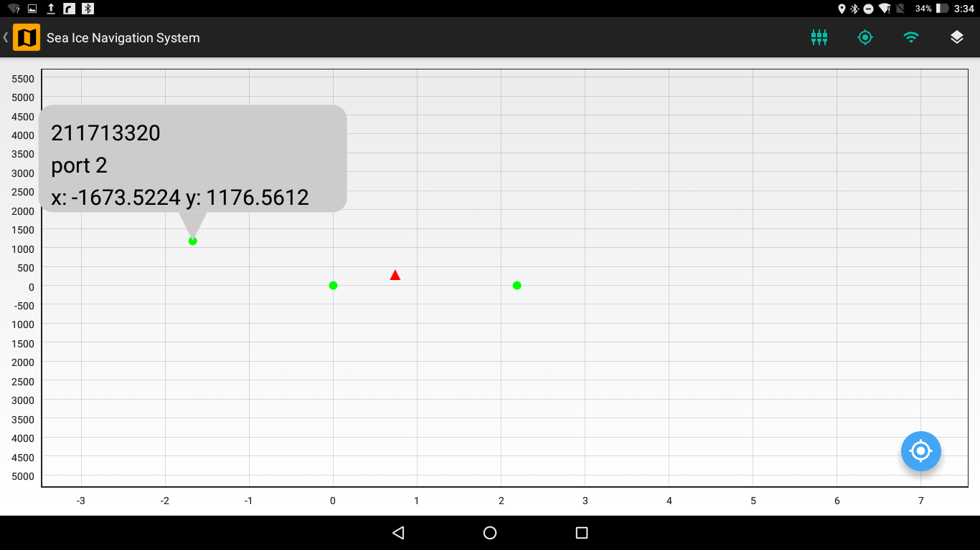

Figure 7.5 Fixed Stations on the Map View

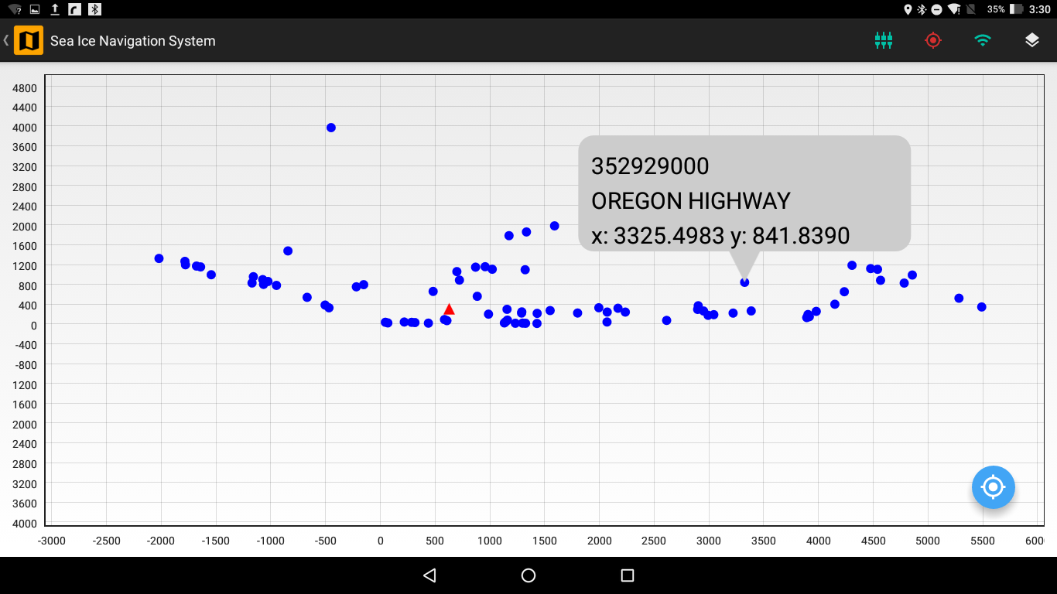

Figure 7.6 Mobile Stations on the Map View

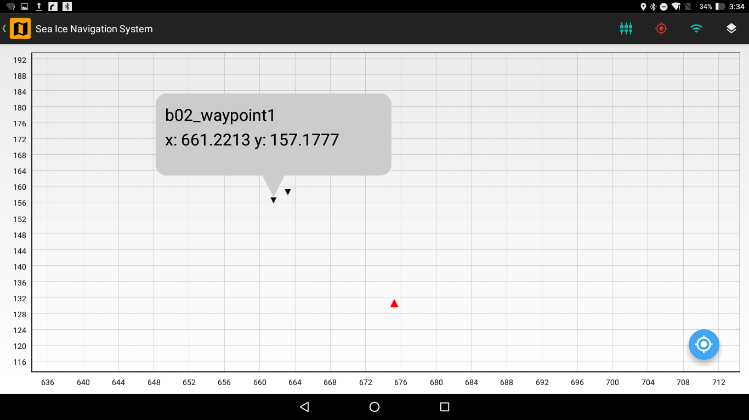

Figure 7.7 Waypoints on the Map View

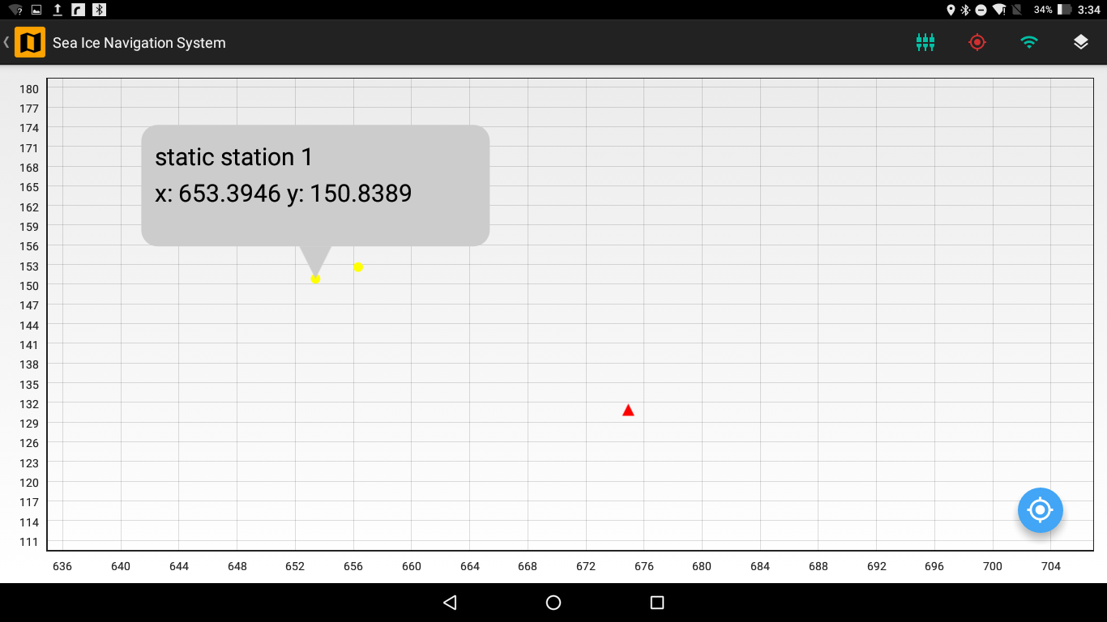

Figure 7.8 Static Stations on the Map View

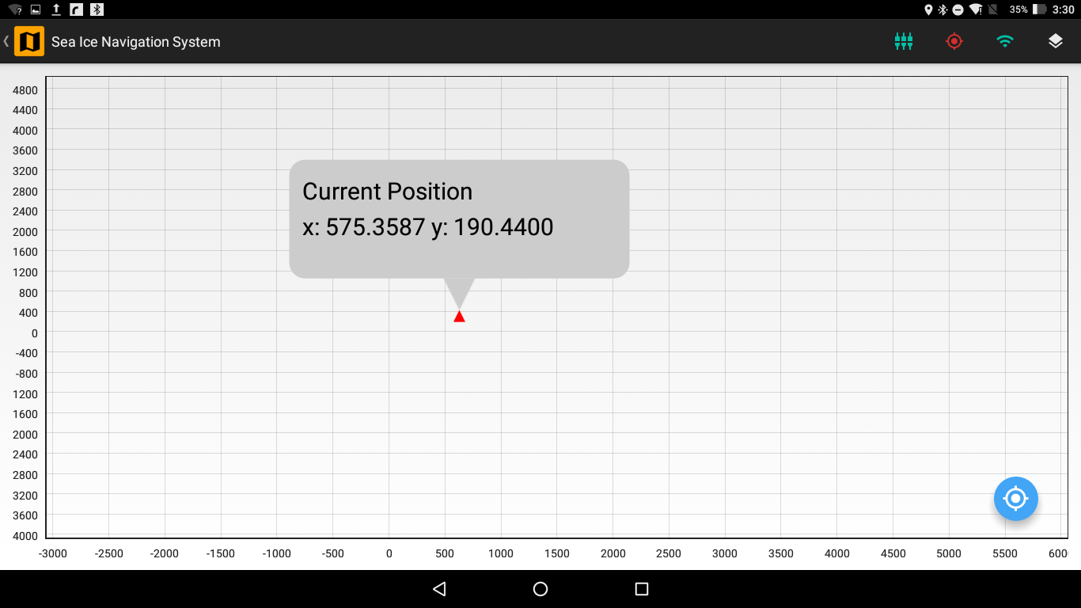

Figure 7.9 Own Position on the Map View

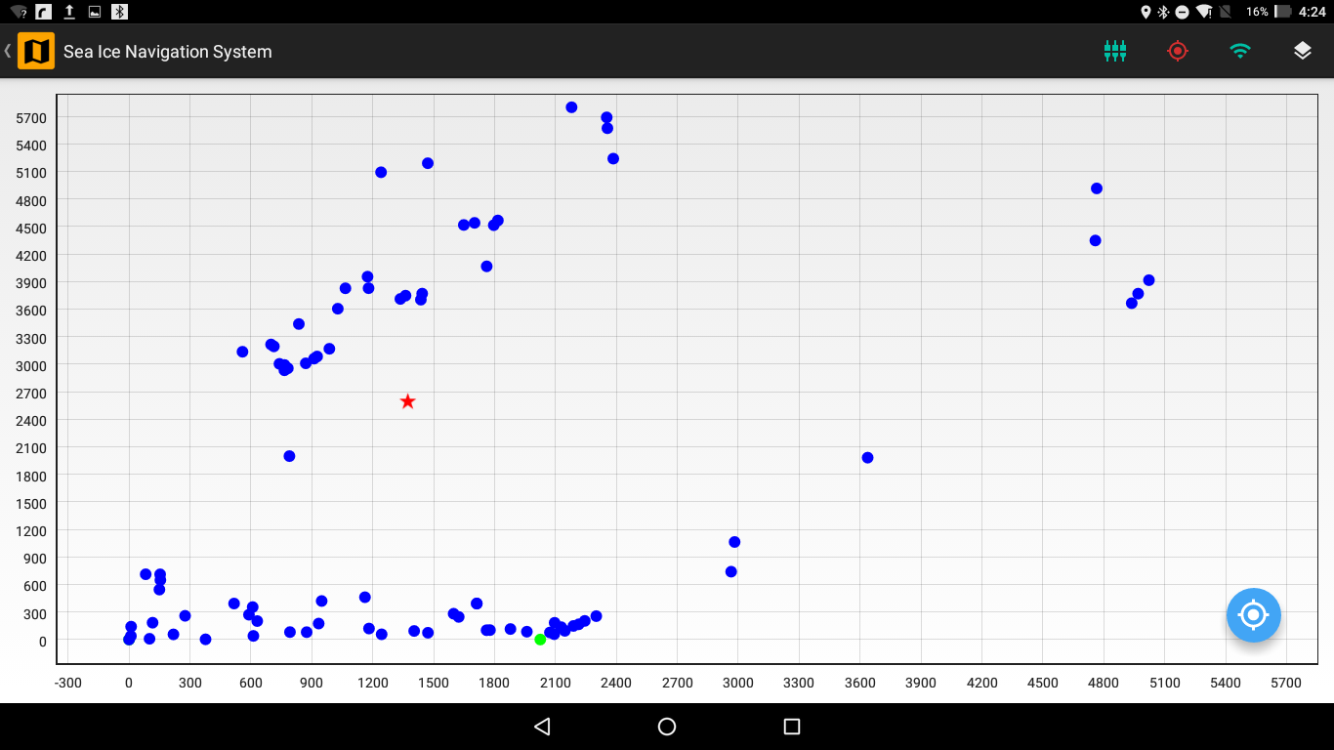

Figure 7.10 Mother Ship on the Map View

#### Details Box

When you tap a station or a point of interest the *Details Box* appear which shows the details of that station or point of interest. The *Details Box* displays the name of station/point of interest if exists, MMSI (only for a station with AIS such as Fixed Stations and Mobile Stations) and {x, y} coordinates of the station/point of interest in meters.

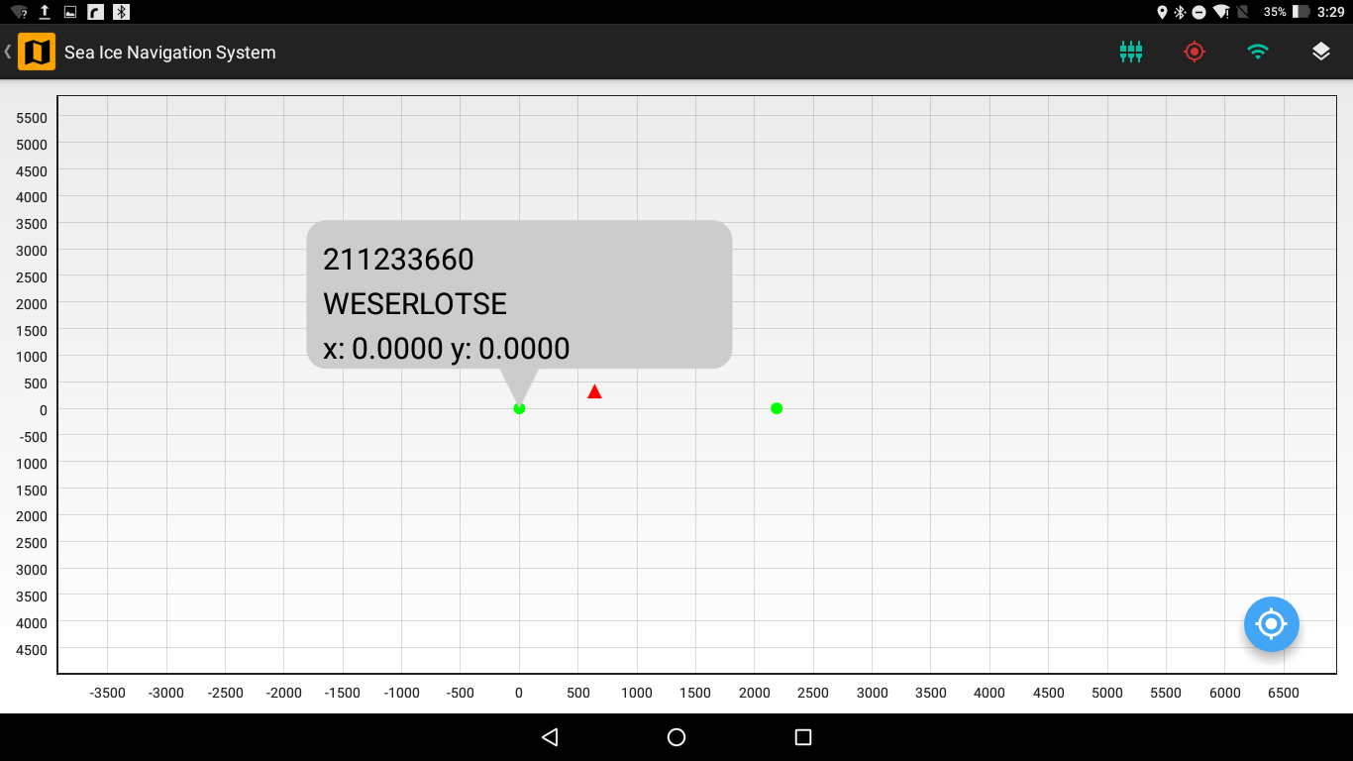

Figure 7.11 Details Box of a Fixed Station on the Map View

#### Zoom & Pan

You can zoom and pan on the map view. So as to locate a specific station/point of interest you can zoom in to the map view and tap that station/point of interest to see its *Details Box*. You can also move the map view when zoomed in using the pan feature.

#### Focus Button

There is a Focus Button on the Map View which will focus the map view either on your location if your location is available via GPS of the tablet or on the origin if GPS location is not available. The map view will be focused on a 5km radius of either your location or the origin.

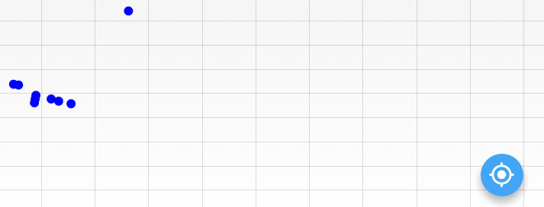

Figure 7.12 Focus Button on the Map View

# Deployment

This Chapter describes the deployment of Static Stations in the Floe Navigation System.

Static Stations are fixed points on the Sea Ice where any equipment or structure has been installed without an AIS Transponder; therefore, these Static Stations are not used by the App to maintain the coordinate system. Each Static Station is identified by a unique name. The Static Station can be of type Tent, Hut, Mast or a Fixpoint. Each Static Station has a {x, y} coordinate pair associated with it.

You can install a new Static Station by tapping on the Deployment button on the Main Dashboard which opens the Deployment screen. Static Stations once installed can only be deleted by an administrator (For details see Floe Navigation Administrator Guide).

You should specify a unique name for each Static Station. The App deploys a static station at the current location of the tablet which is available via GPS. The Deployment screen shows the current location of the tablet in the current Latitude and Longitude fields of the screen. The software is designed in such a way that the latitude and the longitude fields will be automatically updated when you move with the tablet. If the location is not available the current Latitude and Longitude Fields will be set to 0.00.

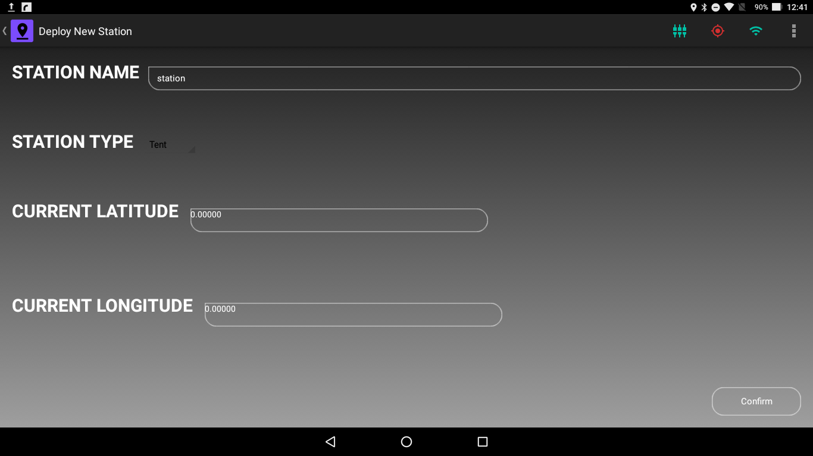

Figure 4.1 Deployment of a Static Station when Tablet location is not available

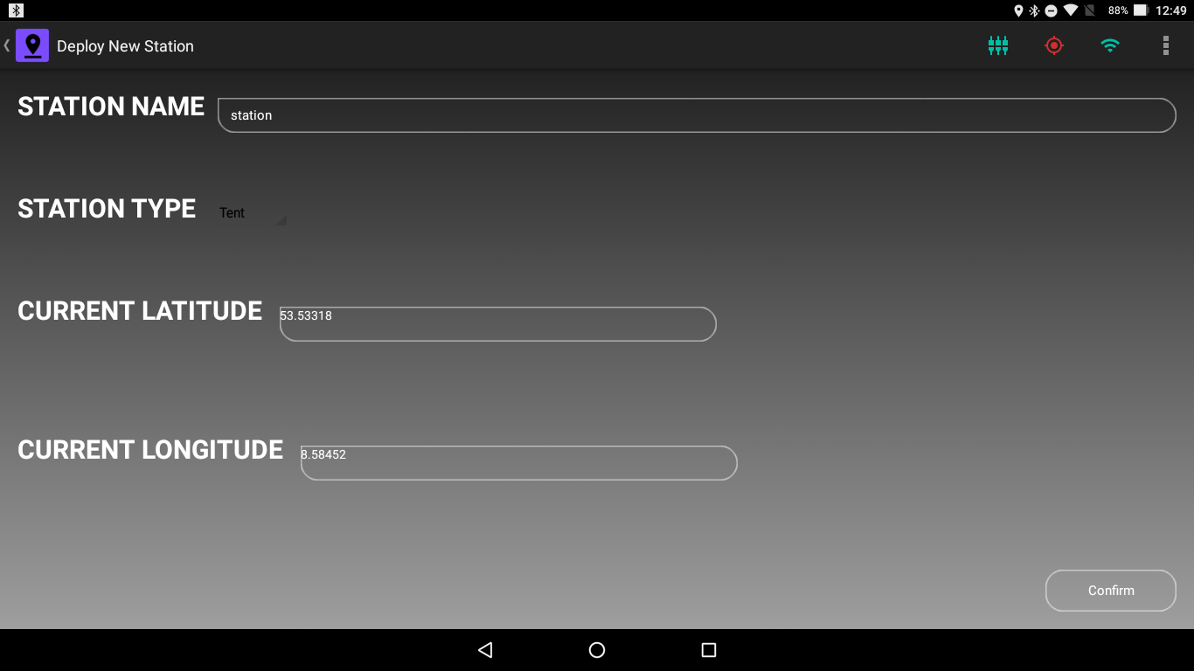

Figure 4.2 Deployment of a new Static Station when Tablet Location is available via GPS

A Change Lat/Lon Format button is available in the Status Bar to change the format of the displayed coordinates.

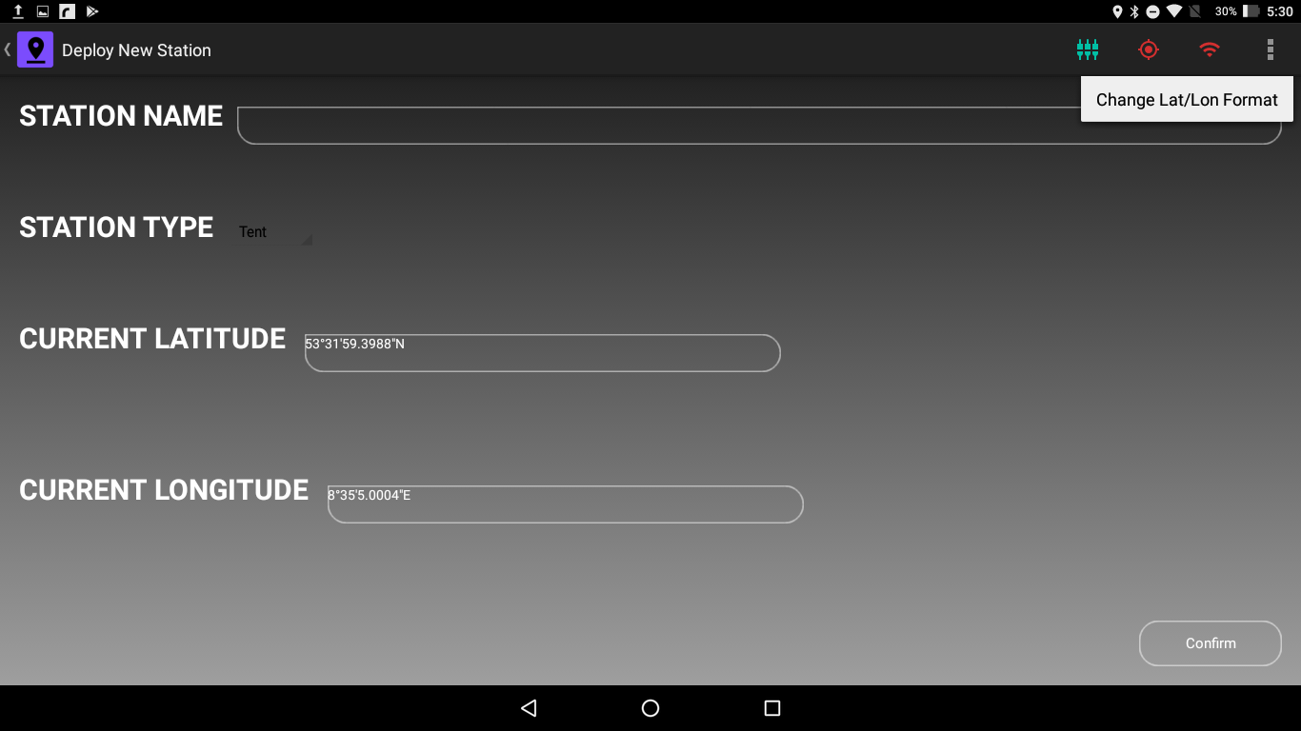

Figure 4.3 Chane Lat/Lon Format Button in the Status Bar

To set the station type tap on the Station Type field which will show the type of stations which can be installed.

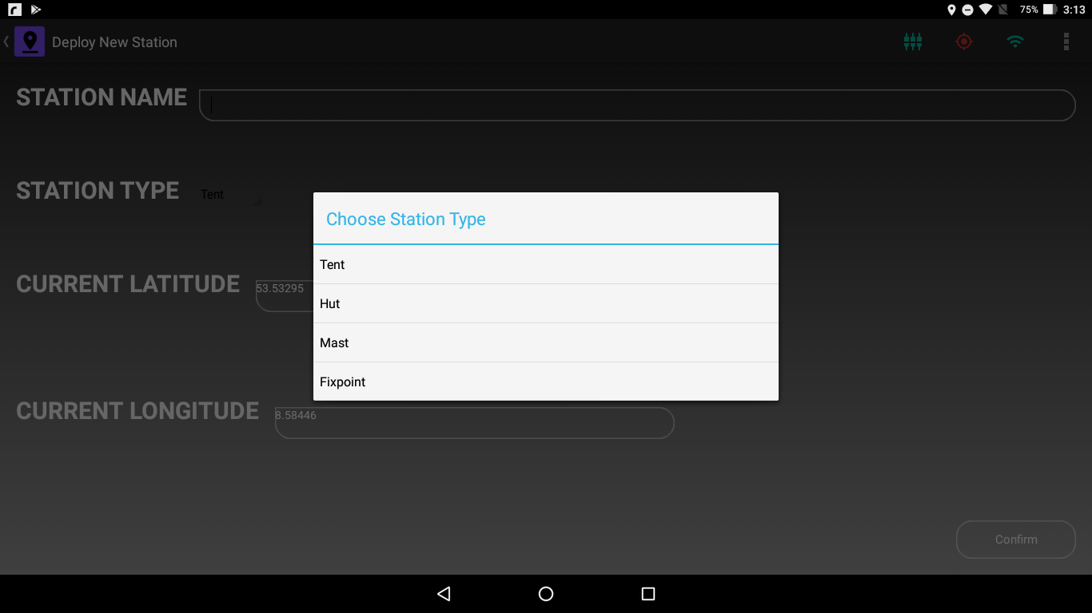

Figure 4.4 Static Station Types

Pressing the Confirm button at the bottom right of the screen will install the new Static Station. If location is not available and the Confirm button is pressed, the App will not deploy the static station and will show an error message. When the tablet location is available, Station Name and Type are correctly set and then Confirm button is pressed, the App will calculate the {x, y} coordinates from the tablet location and install a Static Station at those coordinates.

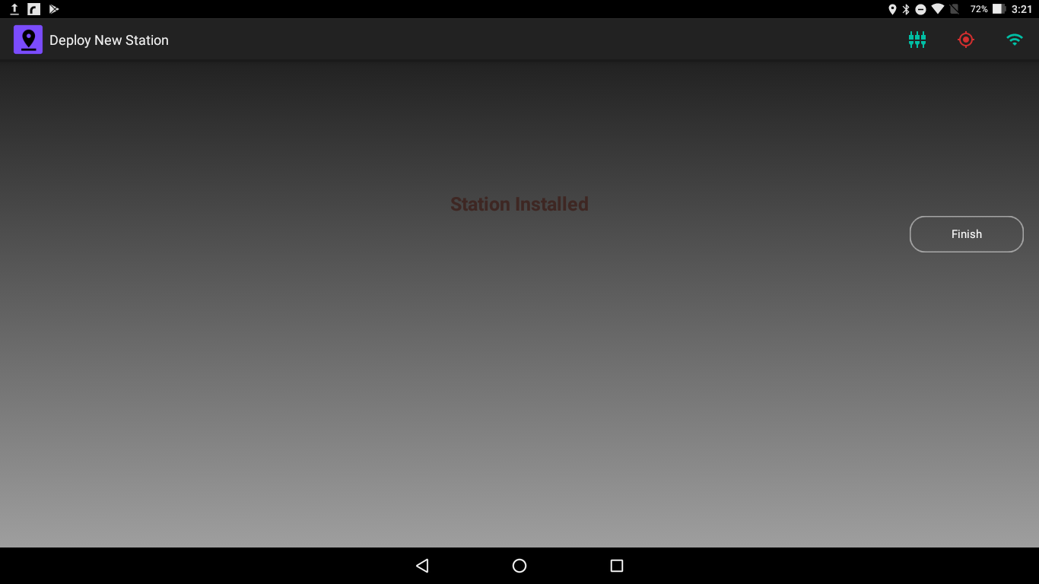

Figure 4.5 Successful Deployment of a Static Station

Pressing the Finish button will take you back to the Main Dashboard.

# Waypoint

This Chapter describes the installation of Waypoints in the Floe Navigation System.

Waypoints are marked points of interest on the Sea Ice. Waypoints can be used to specify points along a track on the ice, or a single point where measurement can be taken in the future or it can also be used to marked danger zones or sensitive spots on the ice. Waypoints do not have an AIS data and hence are not used by the App to maintain the coordinate system. Each Static Station is identified by a label. The label of the Waypoint is appended with the Tablet’s unique identifier to make it unique across the Floe Navigation System. The Waypoint label is stored internally along with a time stamp and the {x, y} coordinates.

You can install a new Waypoint by tapping on the Waypoint button on the Main Dashboard which opens the Waypoint screen. Unlike Static Stations you (the user) can delete the Waypoints.

You should specify a unique label for each Waypoint. The App deploys a waypoint at the current location of the tablet which is available via GPS. The Waypoint screen shows the current location of the tablet in the current Latitude and Longitude fields of the screen. The software is designed in such a way that the latitude and the longitude fields will be automatically updated when you move with the tablet. If the location is not available the current Latitude and Longitude Fields will be set to 0.00.

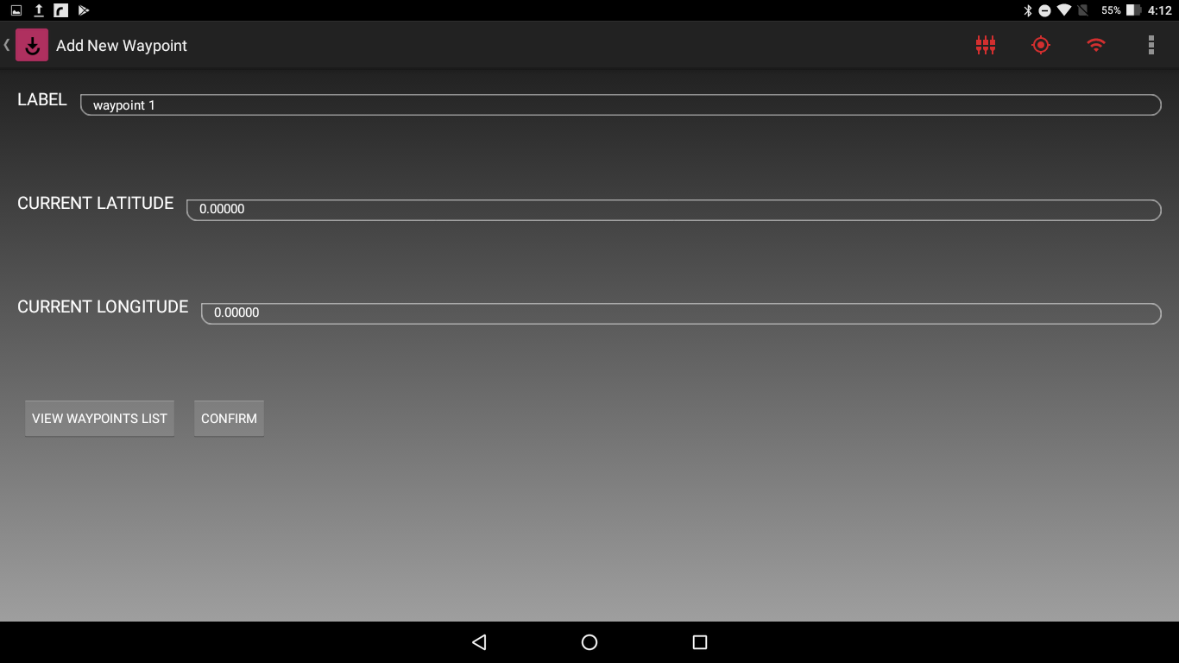

Figure 9.1 Waypoint Installation when Tablet Location is unavailable

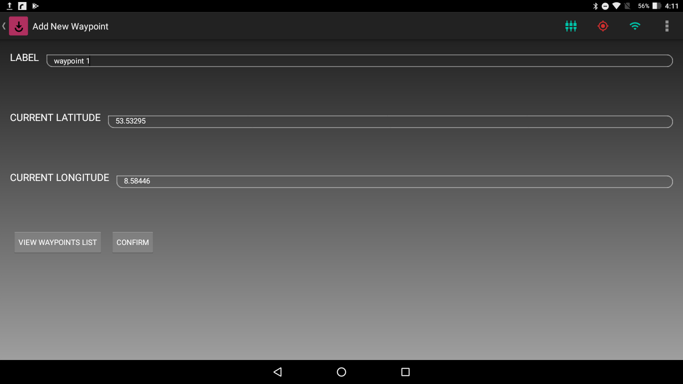

Figure 9.2 Waypoint Installation when Tablet Location is available

Just as in the Deployment screen there is a Change Lat/Lon Format button in the Status bar to change the format of the displayed coordinates.

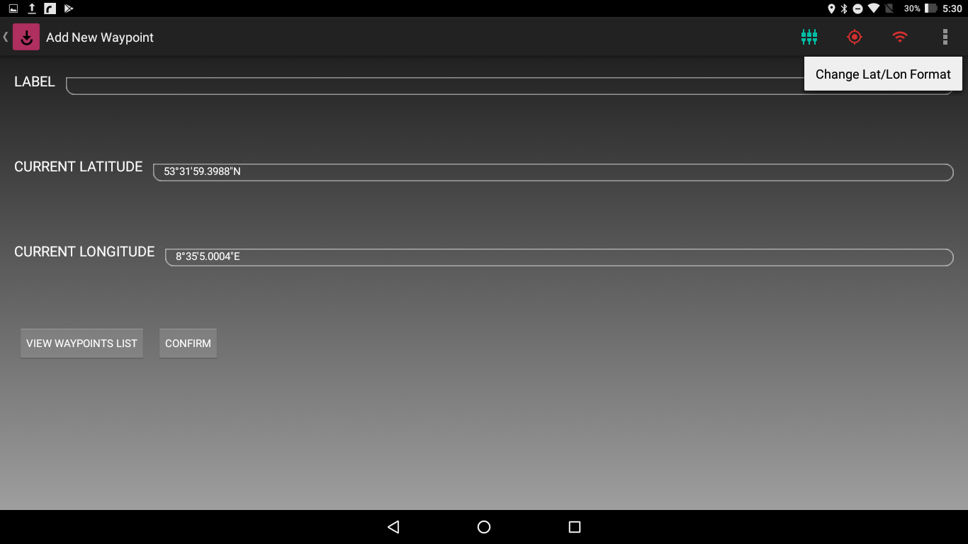

Figure 9.3 Change Lat/Lon Format Button in the Status Bar

Pressing the Confirm button at the bottom of the Waypoint installation screen will install a new Waypoint. If location is not available and the Confirm button is pressed, the App will not install a waypoint and will show an error message. When the tablet location is available, Waypoint label and Type are correctly set and then Confirm button is pressed, the App will calculate the {x, y} coordinates from the tablet location, create a Time Stamp in UTC, and install a Waypoint at those coordinates.

Pressing the Finish Button will take you back to the Main Dashboard.

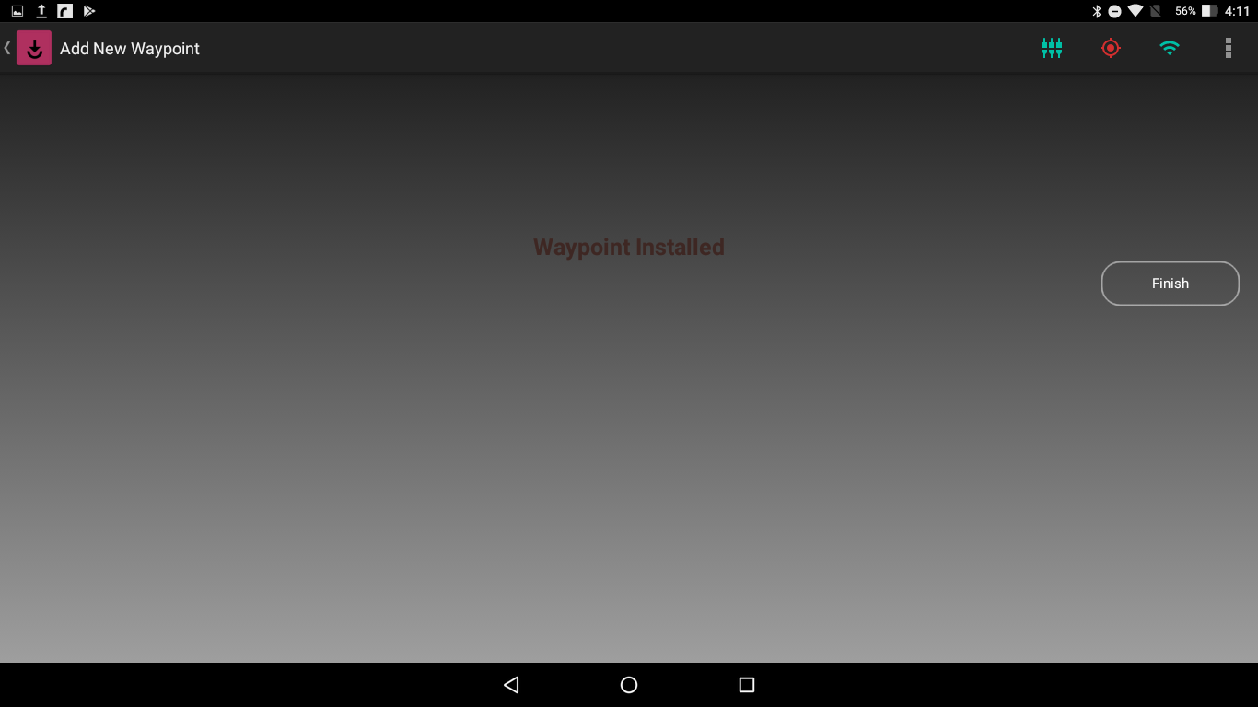

Figure 5.4 Successful Installation of a Waypoint

You can view the all the waypoints installed in the Floe Navigation system by tapping on the *View Waypoints List* button at the bottom left of the screen. This will show all the Waypoints that have been installed on that tablet and waypoints that have been installed on other tablets, provided the App has been synchronized with the Floe Navigation Sync Server. For details check Floe Navigation Administrator Guide. The Waypoint list will show all the waypoint labels, appended with the Unique device ID and their respective {x, y} coordinates.

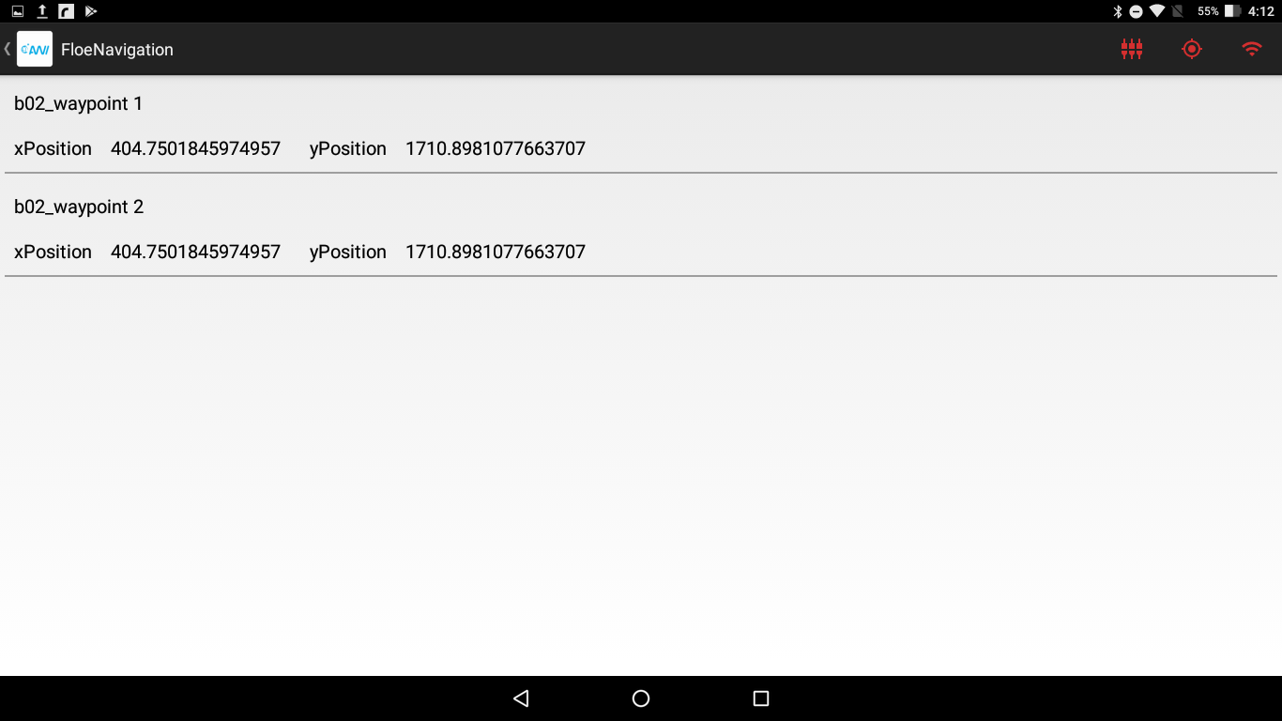

Figure 5.5 List of all Waypoints Installed

In order to Delete a Waypoint, simply swipe right on that waypoint and the waypoint will be deleted. (Please keep in mind that the deletion of the Waypoint will not be reflected in other tablets by default and it will be deleted in other tablets after Synchronization with the Floe Navigation Sync Server. For Details see Floe Navigation Administrator Guide).

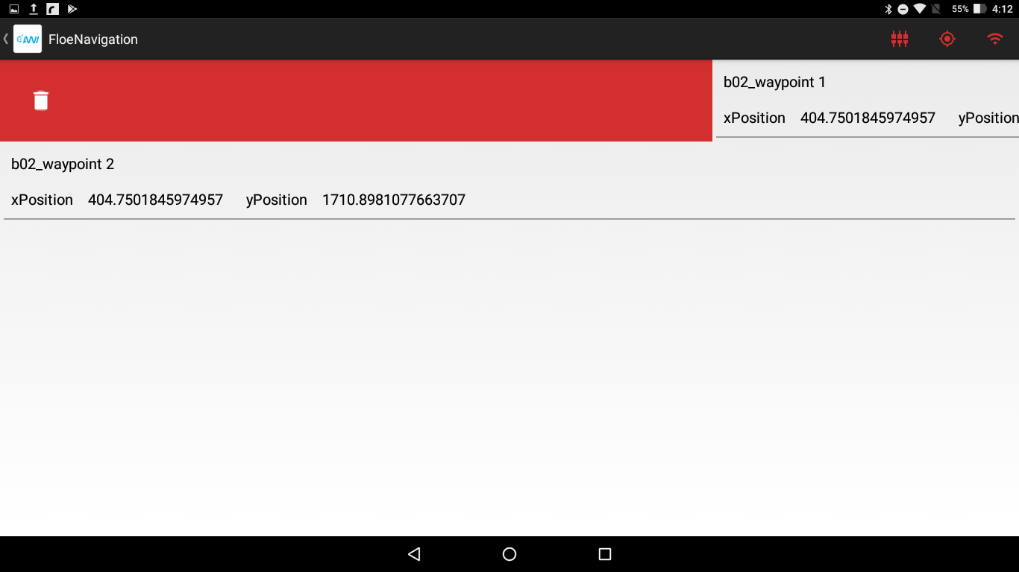

Figure 5.6 Deletion of Waypoint

# Sample/Measurement

This Chapter describes taking Sample/Measurement with the Floe Navigation System.

The Floe Navigation System can also be used to manage Samples which are taken on the Sea Ice. For each sample it can store the device details with which the sample was taken, whether it was a sample or a measurement, and the location data along with the timestamp and a free text label. The details of all the sample stored in the system are available on the Floe Navigation Sync Server. The location data stored contains the Latitude, Longitude (Geographic Coordinates) at the time the sample was taken and the local {x, y} Coordinates.

To use the Sample/Measurement section of the Floe Navigation App you must first import devices in to it. By default, the Floe Navigation App does not contain any devices and it will only import new devices from the Floe Navigation Sync Server during Synchronization. For details see Floe Navigation Administration Guide. If there are no devices in the Floe Navigation App the Sample/Measurement section of the App is disabled.

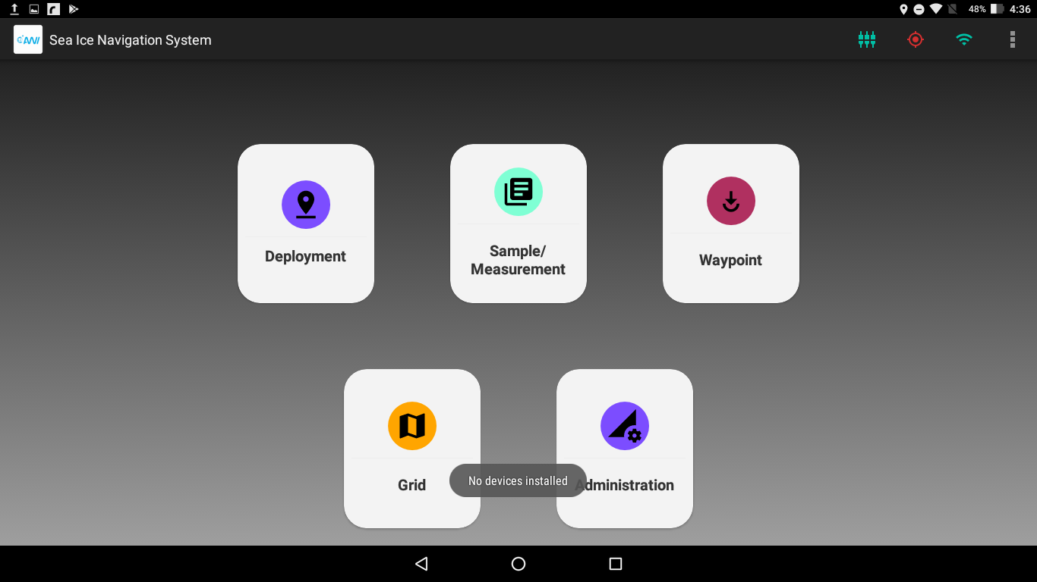

Figure 10.1 Sample/Measurement is disabled when no devices are imported

Once devices have been imported from the Floe Navigation Sync Server, you can create a new Sample/Measurement by tapping on the Sample/Measurement button on the Main Dashboard which opens the Sample/Measurement screen.

You should select the operation being performed whether it is a sample or a measurement. A free text label field available to store further details.

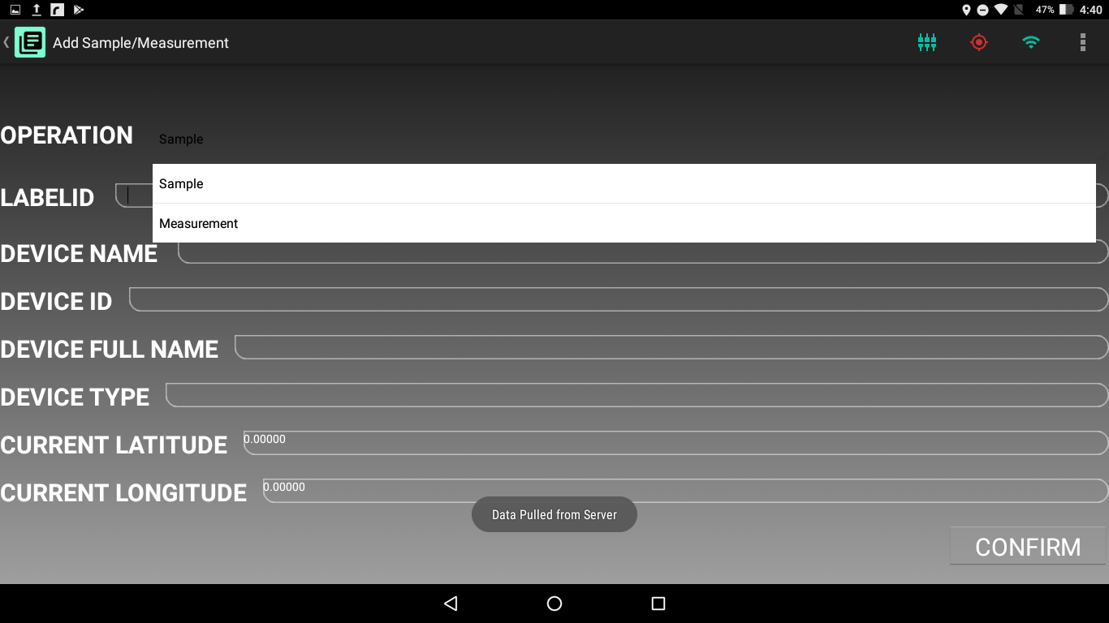

Figure 10.2 Operations Available in Sample/Measurement

Tapping on the Device Name field will show all the available devices in the app and as you type in the field the app filters the Device List to only show matching devices.

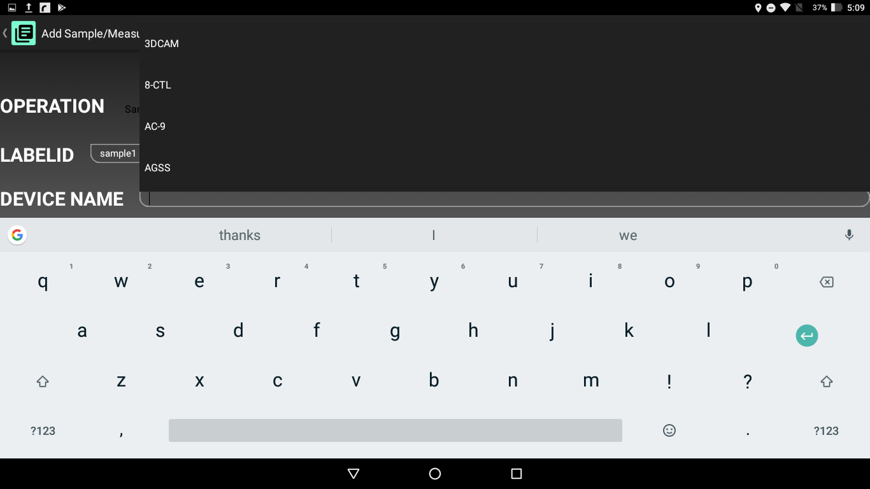

Figure 10.3 Tapping on the Device Name shows the Complete Device List

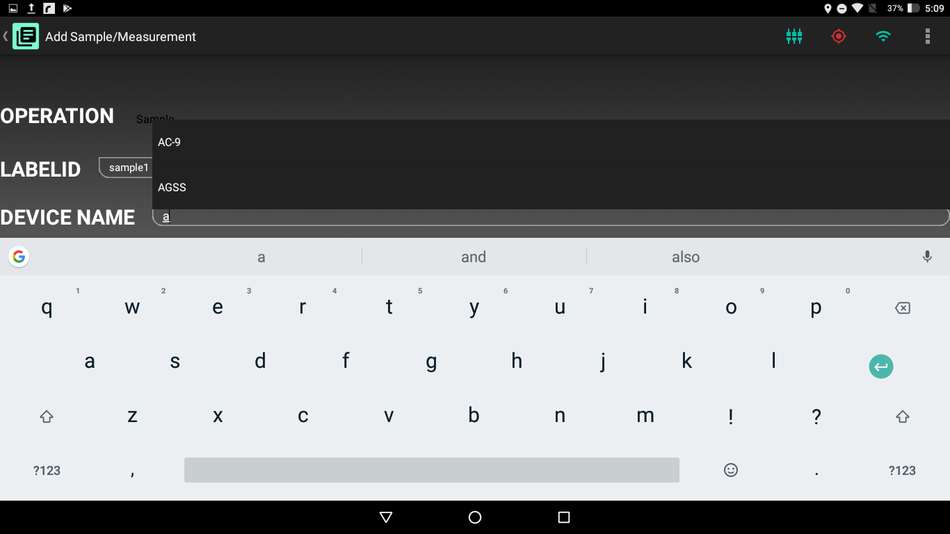

Figure 10.4 Devices are filtered when you start typing Device Name

Once you select a device the other device related details are filled automatically.

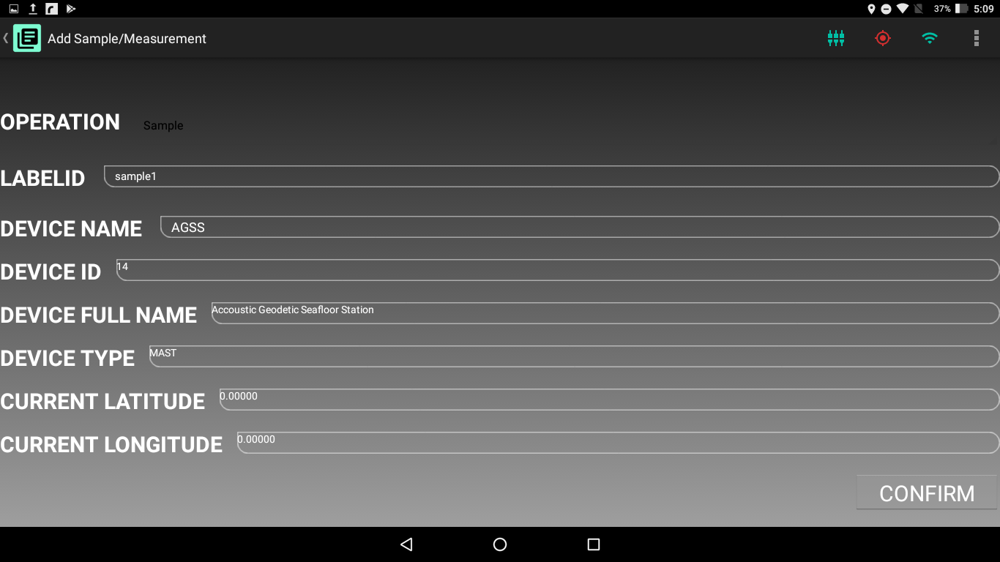

Figure 10.5 Device Details are automatically filled when a Device is selected

Similar to Waypoints and Static Stations it is not possible to take Sample/Measurement when the tablet location is not available via GPS.

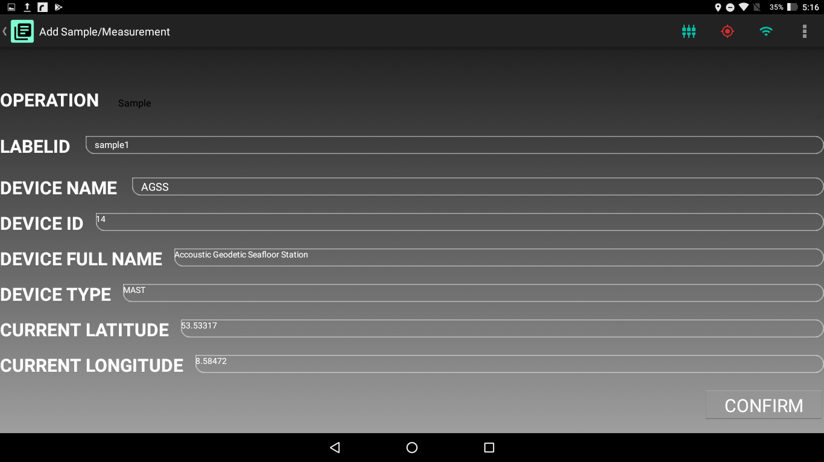

Figure 10.6 Taking a Sample when Device Location is Available

Just as in Waypoint and Deployment screens there is a Change Lat/Lon Format button in the Status bar to change the format of the displayed coordinates.

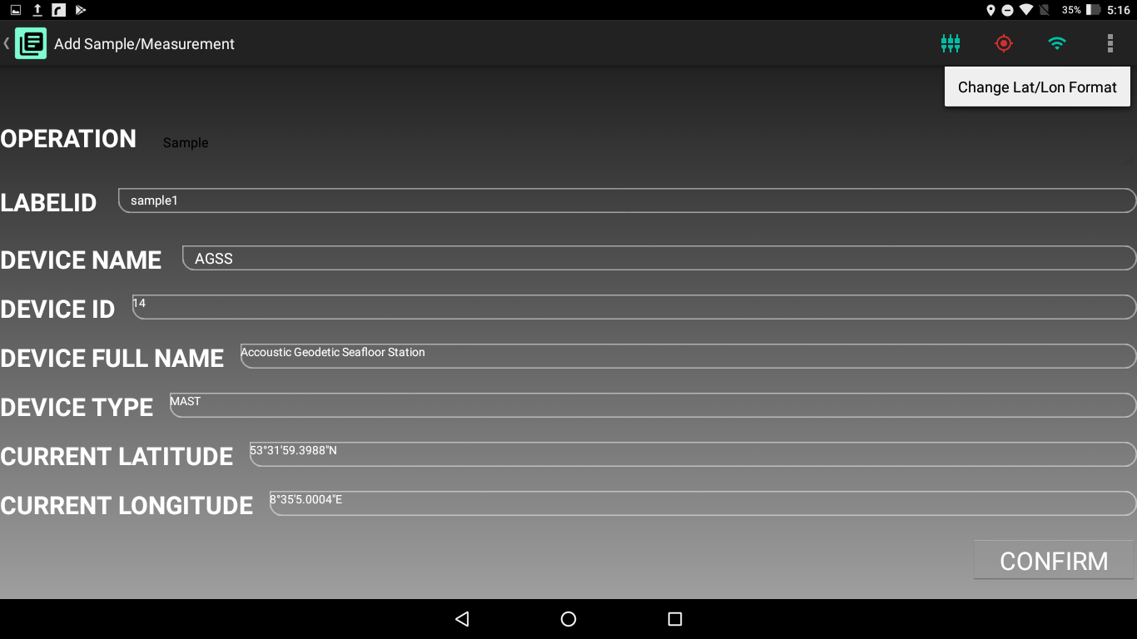

Figure 10.7 Change Lat/Lon Format button in Status Bar

When the tablet location is available, the label is filled and device details are correctly set and then Confirm button is pressed, the App will calculate the {x, y} coordinates from the tablet location, create a Time Stamp in UTC, and store a Sample/Measurement with those coordinates in its local Database and the Main Dashboard is opened.